**<Re:Book>**

**Software Development Plan**

**Version <1.0>**

**Revision History**

| **Date** | **Version** | **Description** | **Author** |
| --- | --- | --- | --- |
| <22/10/2021> | <1.0> | <Initial version of project plan document> | <Dinh Dinh, Khoi Quach, Ngan Nguyen, Thu Nguyen, My Le> |
|  |  |  |  |
|  |  |  |  |
|  |  |  |  |

**Table of Contents**

**Introduction** **4**

**Project Overview** **4**

*Project Purpose, Scope, and Objectives* *4*

*Assumptions and Constraints* *5*

*Project Deliverables (delivery date)* *5*

**Project Organization** **5**

*Organizational Structure* *5*

*Roles and Responsibilities (add Description)* *5*

**Management Process** **6**

*Project Estimates* *6*

*Project Plan* *6*

*Project Monitoring and Control* *7*

Reporting: 7

Risk Management 7

Configuration Management: 8

**Software Development Plan**

# 

# **Introduction**

* 1. **Purpose:**

The purpose of the Software Development Plan is to gather all information necessary to control the project. It describes the approach to the development of the software and is the top-level plan generated and used by managers to direct the development effort.

The following people use the Software Development Plan:

• The project manager uses it to plan the project schedule and resource needs, and to track progress against the schedule.

• Project team members use it to understand what they need to do, when they need to do it, and what other activities they are dependent upon.

* 1. **Scope:**

This Software Development Plan describes the overall plan to be used by the Re:Book project, including deployment of the website.

The plans as outlined in this document are based upon the product requirements as defined in the Vision Document.

**1.3 Overview:**

This Software Development Plan contains the following information:

Project Overview — provides a description of the project's purpose, scope, and objectives. It also defines the deliverables that the project is expected to deliver.

Project Organization — describes the organizational structure of the project team.

# **Project Overview**

## **Project Purpose, Scope, and Objectives**

* + 1. **Purpose:**

Goodreads is the world’s largest site about reviewing and sharing the idea of books in the community of book lovers. Inspired by Goodreads, our team wants to create a website that inherits this meaningful idea. In addition, we expect to express the content of our web page based on a better UI than the one of Goodreads as well as add in several awesome features. Therefore, it may attract newcomers and provide them with a convenient experience.

* + 1. **Scope**:
* Target users: For anyone who loves reviewing books and bookaholics.
* Environment: Website Platform
* Language: HTML, CSS, Javascript
* UI Design: Figma
* Framework: React.js
* Backend: Firebase

## **Assumptions and Constraints**

* All team members will be available in all meetings.
* Guarantee to connect with all team members and listen to their ideas
* The Re:Book project will be available at the end of December, 2021 without bugs.
* No budget
* The project has 5 people and there are no more people added into the project.

## **Project Deliverables (delivery date)**

* Glossary
* Creative Design Briefs
* User Interface Prototype
* Design UI
* Database Design
* Software Architecture Document
* Test cases
* Test Summary

# **Project Organization**

## **Organizational Structure**

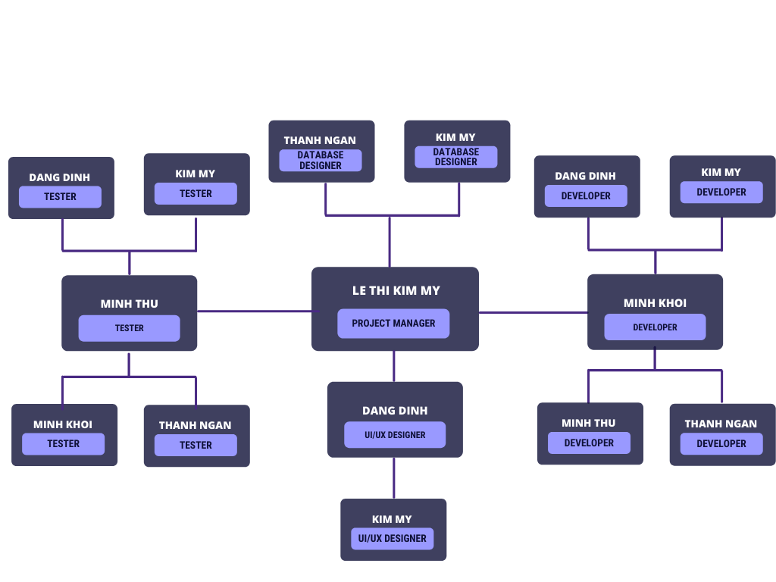

## **Roles and Responsibilities:**

| **Person** | | **Role** | | **Description** |
| --- | --- | --- | --- | --- |
| Lê Thị Kim Mỹ | | Project Manager | | Main role. Responsible for planning and overseeing projects to ensure they are completed in a timely fashion and within budget. |
| UI/UX Designer | | Implement the UI design into code |
| Front-end Developer | | Front-end developer |
| Tester | | Run test scenarios |
| Quách Minh Khôi | | Back-end Developer | | Main role. Responsible for a server, an application, and a database. |
| Tester | | Run test scenarios |
| Đinh Đăng Định | | UI/UX Designer | | Main role. Sketch and design in detail the user interface |
| Front-end Developer | | Front-end developer |
| Tester | | Run test scenarios |
| Nguyễn Thanh Ngân | | Fullstack Developer | | Main role. Responsible for mainly back-end development. Support other members with front-end |
| Database Designer | | Responsible for implementing the detailed database |
| Tester | | Run test scenarios |
| Nguyễn Minh Thư | | Back-end Developer | |  |
| Tester | | Main role. Responsible for designing test scenarios for software usability, running these tests, and preparing reports on the effectiveness and defects to the production team. |

# **Management Process**

## **Project Estimates**

| Estimated cost | | None specified | |
| --- | --- | --- | --- |
| Schedule time for the project | | 10 weeks (for 5 Sprints) | |
| Re-estimated | |  | |

## **Project Plan**

* Gantt Chart: <https://docs.google.com/spreadsheets/d/1Y07jQu1VHGC9El-40fNvyDBNygTfk7rhKhDnIMotz8k/edit#gid=1115838130>
  + 1. *Inception*

1. *PA1*

| PA1 | | |
| --- | --- | --- |
| Start Date | 17/10/2021 | |
| End Date | 30/10/2021 | |

Outcome:

* Write project plan document
* Write vision document
  + 1. *Elaboration*

1. *PA2*

| Start Date | 31/10/2021 | |
| --- | --- | --- |
| End Date | 13/11/2021 | |

Outcome

* Write detailed vision document
* Draw use-case diagram
* Write use-case specification document

1. *PA3*

| Start Date | 14/11/2021 | |
| --- | --- | --- |
| End Date | 27/11/2021 | |

* + 1. *Construction*

1. *PA4*

| Start Date | 28/11/2021 | |
| --- | --- | --- |
| End Date | 11/12/2021 | |

1. *PA5*

| Start Date | 12/12/2021 | |
| --- | --- | --- |
| End Date | 25/12/2021 | |

## **Project Monitoring and Control**

### *Reporting:*

### Weekly Meeting:

Week 1: <https://docs.google.com/document/d/1u0zsnBuWt060b3OL2tI4xb_EYxDLBwC9joKKMiPLY3g/edit?usp=sharing>

Week 2:

<https://docs.google.com/document/d/1IW2ofX2x7gIdFWHF73umYvCrN3-h3pafyFZYD6sQrfY/edit?usp=sharing>

### Weekly status report:

### *Risk Management*

| *Risk ID* | *Risk Description* | *Probability* | *Impact* | *Priority* | *Mitigation Strategy or Contingency Plan* |
| --- | --- | --- | --- | --- | --- |
| *1* |  |  |  |  |  |
| *2* |  |  |  |  |  |
| *3* |  |  |  |  |  |

### *Configuration Management:*

* Team Google Drive folder: <https://drive.google.com/drive/folders/1wjKgLX4Be3KfQlT0UZk36YoSalgMqEuB?usp=sharing>
* Github: <https://github.com/ltkmy19/CS300-SE-group05.git>
* Trello: <https://trello.com/b/A5dccDQe/group05>